The complete RHIS curriculum is available here: https://www.measureevaluation.org/our-work/routine-health-information-systems/rhis-curriculum
7.1.5
Aspects of HIS/RHIS Strategic Planning
and Policy

Nature of These Processes
- HIS/RHIS strategic planning is becoming increasingly structured and formalized, and is being increasingly undertaken by ministries of health.
- This expanding use is largely due to the following factors:
  - The expanding tools and practice of HIS/RHIS assessment
  - The existence of guidelines for HIS strategic planning
  - The expansion of eHealth and mHealth technology
  - The improving technology for data flow, storage, and management
  - Donor interest in supporting national HIS strategic planning
- RHIS operating at the peripheral health service levels emerges from HIS strategic planning as one of the more important HIS subsystems.
- RHIS planning and design generally take place as an early strategic intervention defined as being of priority importance by the HIS strategic planning process.
- HIS/RHIS policies evolve from and support the HIS strategic plan. In addition, new policies and regulations may be formulated between plan periods in order to address gaps in HIS/RHIS performance.
Characteristics, Steps, and Products of HIS/RHIS Strategic Planning
- Purpose. An HIS strategic planning process normally is undertaken by ministries of health that wish to identify and enhance the more important HIS functions and subsystems. The product of the planning process is usually a document spelling out the priority needs for HIS development, agreed strategic interventions and development efforts planned for a five-year period along with estimated development and operational costs, and the definition of program responsibilities for plan implementation.
- Sponsorship, Management, and Organization
  - The HIS strategic planning process is normally sponsored by the health ministry or by a higher level office if more than one ministry is participating.
  - The management and organization of the process is normally structured similar to the following, with participation as indicated:
    - An HIS development steering committee oversees the progress and products of the planning process and provides policy guidance. It comprises 12–20 senior policymakers from all ministries involved; bureaus and institutes external to and from the health ministry with important information management functions (census bureau; civil registration and vital statistics); and directors-general of relevant departments. Senior representatives of international and donor agencies supporting the information system are also useful on this committee.
    - An HIS core team provides the technical management of the process and all of its steps. Normally it comprises six to eight managers and senior technical staff of the principle departments that will be implementing system improvements, such as:
      - The health ministry’s health information department
      - The census planning and analysis department
      - The department of civil registration of the ministry of interior
      - Other departments and institutes heavily engaged in social and health measurement
      - Technical advisors engaged by the health ministry
    - The HIS stakeholder working group (SWG) carries out the technical discussions for each step of the process and produces the required products. It has 40–60 members from offices and programs that are in a position to contribute to the design of information system improvements, and who will eventually take responsibility for implementing the strategies and activities that fall in their functional areas of work. These normally include offices such as policy and planning, budgeting and financial management, HR management, monitoring and evaluation, disease surveillance, major health programs and service areas, other ministries and departments as appropriate, important health nongovernmental organizations and representatives of the private sector, and external technical and donor agencies interested in the subject.
- Guiding Principles
  - Country leadership and ownership of the process
  - Defines and addresses country needs and demands
  - Builds on existing initiatives and systems
  - Strives for broad-based consensus through extensive stakeholder involvement
  - Pursues gradual and incremental developmental progress toward the achievement of a long-term vision
- Process Phases, Steps, and Products
Phase I. Preparation
- Establish the process leadership, management, and organization
- Agree on the process steps and products
- Confirm the assessment results that will be used to define information and HIS performance gaps
Phase II. Priority Setting and Planning
Planning Module I
- Produce and summarize the results of the HIS assessment
- Review existing health system priorities and definition of HIS problems
- Inventory of ongoing and planned HIS improvements
- Inventory and assemble information materials required in Planning Module II
Planning Module II
- Identify priority HIS problems by the SWG
- Formulate the HIS vision
- Formulate the HIS improvement objectives
- Define strategic interventions required to achieve objectives
- Devise phasing in of HIS intervention implementation
- Define HIS intervention implementation responsibilities
- Revise and extend the HIS strategic roadmap
Planning Module III
- Working groups produce HIS strategy design details and results specifications
- Develop HIS activity implementation plans
- Estimate HIS strategy development costs
- Design an HIS strategy development monitoring and evaluation framework
- Assemble and finalize the HIS strategic plan document
- The HIS development steering committee and senior ministry decision makers review and approve the strategic plan
Phase III. HIS Strategy Implementation
- Responsible departments and working groups commence work as scheduled
- The HIS core team prepares periodic monitoring reports
- The HIS development steering committee meets periodically to review progress and monitor donor support and resource needs
- The HIS core team convenes the SWG or subgroups to undertake strategy and plan revisions as necessary during implementation

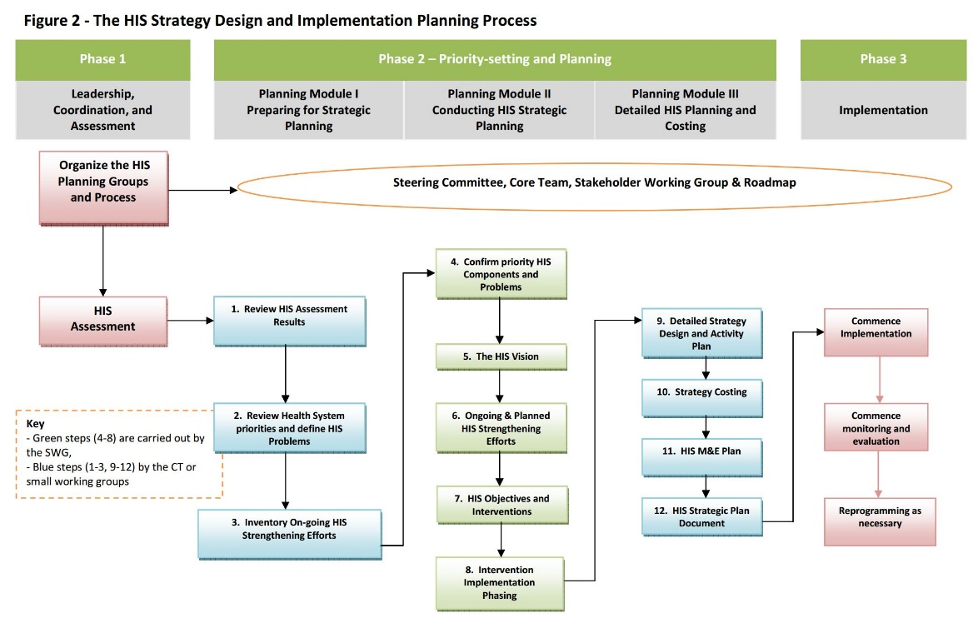
HIS Strategy Design and Implementation Planning Process

Source: Health Metrics Network, World Health Organization. (2009). Guidance for the health information system (HIS) strategic planning process, version 6. Geneva, Switzerland: Health Metrics Network, World Health Organization. Retrieved from https://www.k4health.org/toolkits/hrh/guidance-health-information-systems-his-strategic-planning-process.

Nature and Origins of HIS/RHIS Policy
Definition of Health Policy. Health policy refers to decisions, plans, and actions that are undertaken to achieve specific health goals within a society. An explicit health policy can achieve several things: It defines a vision for the future, which in turn helps to establish targets and points of reference for the short and medium term. It outlines priorities and the expected roles of different groups. And it builds consensus and informs people.
HIS/RHIS Policy. This refers to decisions, plans, and actions that are undertaken to achieve specific HIS development objectives, strategies, and results.
Types of HIS policies That Might Satisfy This Definition
- HIS development vision
- System development objectives and strategies
- Mandated system development interventions and activities
- Guidelines for data recording, reporting, and monitoring requirements, such as core health indicators
- HIS/RHIS reporting requirements placed on service providers and units
- Required HIS/RHIS data use
- Defined HIS/RHIS roles and functions for departments, programs, and service levels and units.

Possible Origins of HIS Policies
- Government legislation, regulations, and procedures
- Health strategies and program-data requirements
- National HIS strategic plans (often combined with HIS policy)
- International health-reporting requirements
- National health-reporting requirements
- National and global health-improvement and service performance goals and targets
- National health-monitoring requirements, such as disease surveillance and health and social surveys

Source: Health Metrics Network, World Health Organization. (2009). Guidance for the health information system (HIS) strategic planning process, version 6. Geneva, Switzerland: Health Metrics Network, World Health Organization. Retrieved from https://www.k4health.org/toolkits/hrh/guidance-health-information-systems-his-strategic-planning-process

