The complete RHIS curriculum is available here: https://www.measureevaluation.org/our-work/routine-health-information-systems/rhis-curriculum
10.1.2
Case Study (60 minutes)
Read the following paper and discuss it in small groups for one hour.
Answer the following questions:
- Who is leading the RHIS strengthening process in Bangladesh?
- Are the RHIS strengthening efforts responsive to the country needs and demands?
- Is the RHIS reform a total rehashing? Or is it building on what exists?
- Was there stakeholder engagement and broad-based consensus?
- Is RHIS integration part of the strategies?

Strengthening the RHIS of the Ministry of Health and Family Welfare, Bangladesh
The Ministry of Health and Family Welfare (MOHFW) of Bangladesh has invested significant resources through its Health, Population and Nutrition Sector Development Program (HPNSDP) in strengthening the country’s routine health information systems (RHIS), particularly building health sector information and communication technology (ICT) across the country. However, two departments within the ministry—the Directorate General of Health Services (DGHS) and the Directorate General of Family Planning (DGFP)—differ in their execution of ICT and their in-house capacities to handle the technology.
Most of DGHS’s field offices, including those at the rural level, have electronic data entry equipment and software solutions for their routine data collection activities. Both DGHS and DGFP use the web services of district and upazilla (subdistrict) offices for data collection and have important initiatives for automating data collection process from the health facilities. DGHS is using DHIS 2— an open source web-based platform for routine data reporting—to collect aggregate data from upazilla health offices. Both DGHS and the Community Clinic Project also collect data from community clinics. At the same time, DGFP is using software solutions to track distribution of reproductive health commodities by frontline health workers. Different development partners have supported these activities, and there are opportunities for providing further support to consolidate the gains as well as to establish a robust data collection system within the scope of HPNSDP’s Monitoring and Evaluation Strategy and Action Plan.
The United States Agency for International Development (USAID) and its implementing partners (MEASURE Evaluation [MEval]/International Centre for Diarrhoeal Disease Research, Bangladesh [icddr,b], Save the Children, and Management Sciences for Health [MSH]) and other development partners (for example, the United Nations Children’s Fund [UNICEF] and the German Federal Enterprise for International Cooperation [GIZ]) are collaborating with DGHS and DGFP. They are contributing to the development of RHIS in Bangladesh, by ensuring that their activities are aligned with the current operations of DGHS and DGFP and contribute to these directorates’ long-term RHIS strengthening goal.
USAID-supported partners (MEval/icddr,b, MaMoni-Health Systems Strengthening [HSS]/Save the Children, Systems for Improved Access to Pharmaceuticals and Services [SIAPS]/MSH) have conducted several initiatives to strengthen the monitoring and evaluation functions of HPNSDP. These initiatives have had several focuses. One has been work on six HPNSDP operation plans (OPs): maternal, newborn, child, and adolescent health; maternal, child reproductive, and adolescent health; National Nutrition Services; community-based healthcare; the Clinical Contraceptive Service Delivery Program; and the Field Service Delivery Program. Others have been to streamline management information systems (MIS) tools to minimize information gaps and duplication; reduce the burden of data collection and compilation; design and use a supply chain management portal for efficient and effective logistics management of reproductive, maternal, newborn, and child health (RMNCH) commodities; improve the capacity of the MIS units of DGHS and DGFP to generate reliable information on time; improve the use of information at the local level; and promote evidence-informed decision making.
A review of the six priority OPs found that routine MIS of the health and family welfare sector covered only half of the original OP-level service indicators. Moreover, service providers and field workers were overburdened with recording and reporting requirements. For example, there were 14 registers for family welfare visitors, 11 key sections in the registers maintained by family welfare assistants; five in-patient monthly reports, which had to be manually aggregated; and at least five monthly reports that health assistants were required to produce. Because computer-based databases were not fully functional, access to data—including the use of RHIS data for local-level decision making—was inadequate. The review of indicators across 32 OPs and development of a performance management plan (PMP) has provided valuable input to the annual performance report (APR) of HPNSDP over the past few years. Indicator reference sheets for 342 indicators were developed that incorporated definition, calculation, unit of measurement, frequency, source of information, and level of data generation. Those indicators were categorized by types, such as training, service, facility readiness, drug/logistic, infrastructure, and workshop/meeting. Further assessment by the MOHFW’s Planning Wing resulted in reduction of OP indicators from 342 to 158.
MaMoni-HSS/Save the Children and MEval/icddr,b put special focus on streamlining and implementing the MIS tools. Registers and report formats were revised and later approved by the DGHS and DGFP, and the reports of health assistants and family welfare assistants were synchronized through the interventions of community volunteers engaged by MaMoni-HSS. As a result, the quality of reporting has improved noticeably. One big challenge, however, is the continued use of both old and revised systems, which affects staff motivation. Encouragement by local-level managers to use the new system was also not adequate.
In contrast, GIZ had been providing technical assistance to DGHS and DGFP to customize, manage, and upgrade DHIS 2 software. In 2008, based on a recommendation from the annual program review of the Health Nutrition and Population Sector Program—the program that preceded HPNSDP—GIZ provided assistance to the MOHFW to develop a well-functioning health information system to incorporate data across all the different levels of the health system. The aim was to connect the fragmented systems by bringing together the data from different databases. GIZ advocated DHIS 2’s customization. The entry and reporting of data from most of the health programs in 4,501 union (basic administrative unit) level facilities for DGHS is under way using a DHIS 2-based MIS.
UNICEF has been implementing the registration of pregnant women and children under five years of age at the community clinic level in three hard-to-reach districts. Pregnant women receive services from different organizations and also move from one place to another. As a result, tracking them is difficult. This creates mismatch in base values and coverage calculations. For example, in one village, the numbers of pregnant women reported by three organizations were different: DGFP recorded 758, DGHS 634, and nongovernmental organizations 1,873. UNICEF decided to use the DHIS 2-based MIS and planned on a step-by-step intervention for HSS. Community clinic registers and the data entry manual were revised to facilitate the community-based registration. All maternal services were captured by one registration, and community-based recording of the cases of children under five years of age was introduced. The system provides a quick view of visit status with color coding, defaulter tracking and priority list, and management of risk cases. All the functionalities are available in software and in registers.

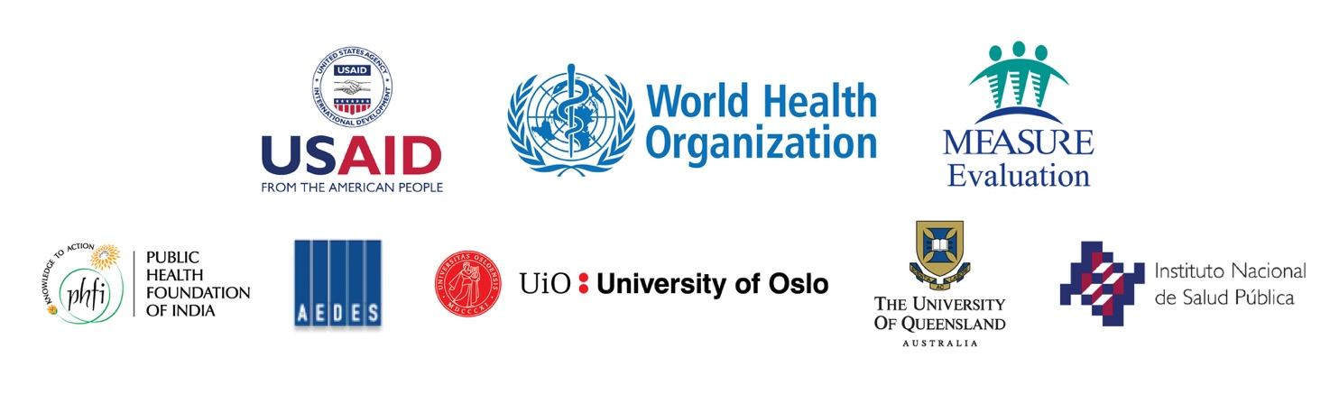

This case study is drawn from Kabir, M.H. & Choudhury, S.K. (2015). Seminar on strengthening the routine health information system of the Ministry of Health and Family Welfare in Bangladesh. Chapel Hill, NC, USA: MEASURE Evaluation, University of North Carolina. Retrieved from http://www.cpc.unc.edu/measure/resources/publications/ws-15-24?searchterm=ws+15+24.

